Adventure Works Project
(MicroStrategy Boot Camp Project)

Exercise Document

10 March 2017

By: MicroStrategy Practice

Document History

Version | Date | Modified By | Summary of Changes
1.1 | 01/03/2017 | Gurpreet Kaur | Created
1.2 | 01/11/2017 | Gurpreet Kaur | Updated
1.3 | 01/10/2017 | Arup Duttaroy | Reviewed
1.4 | 01/23/2017 | Gurpreet Kaur | Updated
1.5 | 03/07/2017 | Arup Duttaroy | Reviewed, reformatted
1.6 | 11/02/2018 | Sushrit Moundekar | Updated
1.7 | 2/27/2019 | Shubhankar Laha | Updated
1.8 | 7/6/2024 | Sushrit | Updated

Table of Contents
1. C and G -KPI by Quarter 4
2. G - Analysis of Products Shipped within selected days of Ordering 4
3. G - Analysis of Sales by Geography and Product Hierarchy 5
4. G - Inventory by Product Category for Year 5
5. G - Sales by Time and Product for the selected Subcategory 6
6. G - Top 5 Product Groups | Top 5 Regions | Top 5 Customers by Sales 6
7. Dashboard – Design a Dashboard 7

C and G -KPI by Quarter

Complexity Level: Medium

Requirement: This report is used to compare quarterly Sales for a given year with the same period last year. It also gives the percentage variance of this year’s quarterly Sales over last year’s.

Instructions:
- Show sales in million in graph and grid view.
- Add Year in ‘Page By’.
- Display Quarter in YYYYQQ format (Ex. Quarter 1 of 2014 should be 2014Q1)
- Use a Dual Axis Combination (Bar-Line) Graph.
- Data should be according to year available in the fact
- “This Year Sales” and “Last Year Sales” need to be represented as bars and Sales Variance (percentage) as a line.
- Add Legend for Variance

G - Analysis of Products Shipped within selected days of Ordering

Complexity Level: High

Requirement: This report displays Product wise Sales for all Orders which are shipped within a certain number of days of ordering. The number of days will be entered by the user.

Instructions:
- Report template should show the Order Date and Ship Date in DD-MMM-YYYY format (12-Jan-2017).
- Show how much each Product contributes to the total Sales of the Category it belongs to in percentage.
- Report should display Products having Sales greater than $6000.
- Show Sales Count for each order as Units Sold. (Sales Count = Order Quantity)
- Report should be sorted in descending order based on the difference of the Order & Ship Dates.

G - Analysis of Sales by Geography and Product Hierarchy

Complexity Level: High

Requirement: This report is required to compare Sales performance across Region & Product Hierarchy for a selected Year.

Instructions:
- The KPIs on which the Region & Product Hierarchy are to be compared are Sales and Average Sales
- Year should be in the Page-By
- Use Threshold to mark Max Sales in Green colour and Min Sales in Red Colour.
- Use threshold at report level
- User should be able to drill down to the Product Level. Ensure the Parent is visible after drilling from Parent to Child
- Threshold and Totals should be carried forward while drilling.
- Show the Total at the bottom of the report.
- Report should be sorted in descending order of Sales at Product Category Level.
- The report should show Subtotal at Product Category level after drilling

G - Inventory by Product Category for Year

Complexity Level: Low

Requirement: This report is required to analyse the Inventory On Hand at the end of each Quarter, by Product Categories. It should also show the percentage share of the Inventory of each Product Category to the Total Inventory.

Instructions:
- Add Year & Product Category in Page By
- Enable drilling in the Time Hierarchy
- Inventory Metric is a special kind of Metric. Demonstrate that speciality when drilling from Quarter to Month level. Show the Parent attribute in the Drilled Report and enable sub-totals as appropriate.

G - Sales by Time and Product for the selected Subcategory

Complexity Level: Medium

Requirement: This report displays Sales by Product for selected Time period. Users should be able to select any of the time period (Year, Quarter, Month) on the fly.

Instructions:
- Report should be prompted for Product Subcategory within a selected Product Category
- The Time granularity of the Report output should be the same level as is selected in the Time period selection prompt.
- In the Prompt, Month Should be displayed in the format <Month Name> YYYY (e.g. January 2016)

Hint: Make the use of the Hierarchy Prompt for time period.

G - Top 5 Product Groups | Top 5 Regions | Top 5 Customers by Sales

Complexity Level: Medium

Requirement: The objective here is to display the Top performing Product Groups, Regions and high value Customers in a single report. The report should display the Top 5 in each of these categories based on Annual Sales figures.

Instructions:
- Use Prompt for Year (Default answer Year = 2016)
- Subtotal should be displayed at the bottom of each category

Dashboard – Design a Dashboard

Requirement:
End User wants to see the following analysis
- Users are trying to analyse data for only three years - 2014,2015,2016
- User wants to compare how the sales performance is as compared to last year sales
- They want to analyse the Sales performance of their various Product Categories for different region. For this they need to see the monthly sales trend of each product categories for a particular region.
- They also want to analyse further Subcategories and Products sold for a particular Category they choose.
- Users want to see top 20 customers for a particular selected product subcategory.
- Add threshold to the main KPIs, if This Year Sales > LY green else red. Last Year Sales should be static Amber

Attached is the mock-up of the dashboard that you need to develop to cater the needs of the end users.
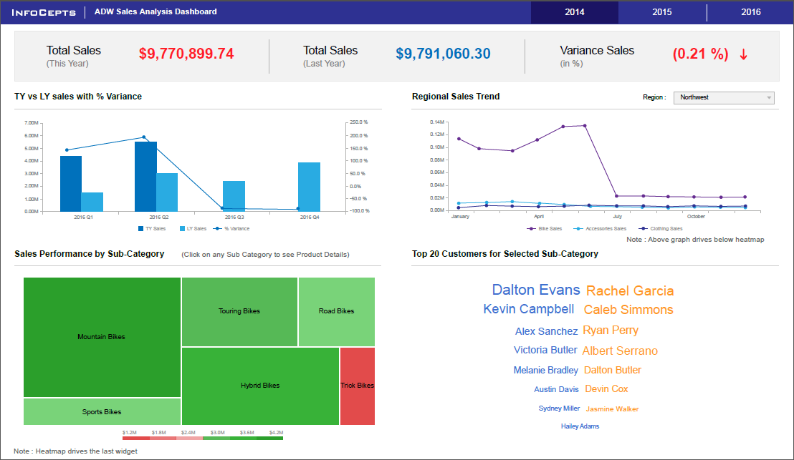
Driving Requirements:
- Region Selector should drive all graphs except the first one (TY vs LY Sales)
- Sales performance by Sub-Category and Top 20 Customers Graphs should be driven by Regional Sales Trend Graph (by attributes Category and Month)
- Top 20 Customers Graph should be driven by the selected subcategory in Sales Performance by Subcategory Graph

Dataset:
